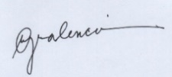
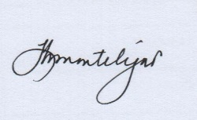
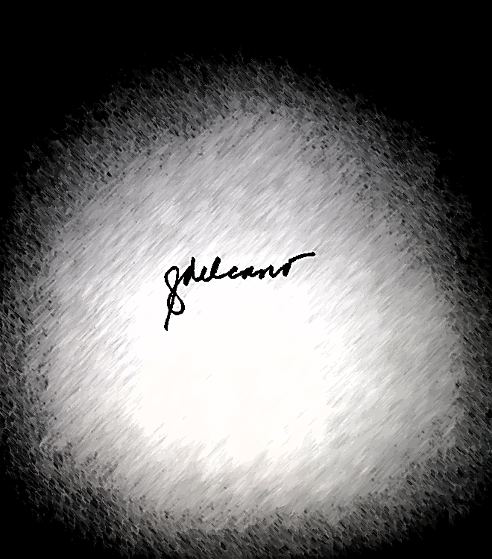

11

General Mathematics
Activity Sheets
Quarter 2 – MELC 6

Distinguishing Between Simple and General Annuities


REGION VI – WESTERN VISAYAS

General Mathematics 11 Activity Sheet No. 06
First Edition, 2020

Published in the Philippines
By the Department of Education Region 6 – Western Visayas

Republic Act 8293, section 176 states that: No copyright shall subsist in any work of the Government of the Philippines. However, prior approval of the government agency or office wherein the work is created shall be necessary for exploitation of such work for profit. Such agency or office may, among other things, impose as a condition the payment of royalties.

This Learning Activity Sheet is developed by DepEd Region 6 – Western Visayas.

ALL RIGHTS RESERVED. No part of this learning resource may be reproduced or transmitted in any form or by any means electronic or mechanical without written permission from the DepEd Regional Office 6 – Western Visayas.
Development Team of General Mathematics Activity Sheet Writer: Rutchel J. Ngipen
Illustrator: Rutchel J. Ngipen

Layout Artist: Rutchel J. Ngipen

Schools Division Quality Assurance Team:
Ligaya H. Montelijao, EPS-Mathematics
Leila G. Valencia, EPS-LR
Jezereel Grace G. Tiron
Bernie P. Alcedo
Division of Iloilo City Management Team:
Ma. Luz M. De los Reyes, SDS
Ernesto F. Servillon Jr., ASDS
Arlo L. Villalva, CID Chief
Dr. Jerry M. Lego, SGOD Chief
Leila G. Valencia, EPS-LR
Ligaya H. Montelijao, EPS-Mathematics
Regional Management Team
Ma. Gemma M. Ledesma, Dr. Josilyn S. Solana,
Dr. Elena P. Gonzaga, Mr. Donald T. Genine, Mr. Adonis Mosquera
Mrs. Rhodalyn Delcano

Introductory Message

Welcome to General Mathematics 11!

The Learning Activity Sheet is a product of the collaborative efforts of the Schools Division of Iloilo City and DepEd Regional Office VI - Western Visayas through the Curriculum and Learning Management Division (CLMD). This is developed to guide the learning facilitators (teachers, parents and responsible adults) in helping the learners meet the standards set by the K to 12 Basic Education Curriculum.

The Learning Activity Sheet is self-directed instructional materials aimed to guide the learners in accomplishing activities at their own pace and time using the contextualized resources in the community. This will also assist the learners in acquiring the lifelong learning skills, knowledge and attitudes for productivity and employment.




For learning facilitator:

The General Mathematics Activity Sheet will help you facilitate the teaching-learning activities specified in each Most Essential Learning Competency (MELC) with minimal or no face-to-face encounter between you and learner. This will be made available to the learners with the references/links to ease the independent learning.




For the learner:

The General Mathematics Activity Sheet is developed to help you continue learning even if you are not in school. This learning material provides you with meaningful and engaging activities for independent learning. Being an active learner, carefully read and understand the instructions then perform the activities and answer the assessments. This will be returned to your facilitator on the agreed schedule.

Learning Activity Sheets (LAS) No. 6
Quarter 2, Week 3

Name of Learner: ___________________ Grade and Section: _________________
Date: _____________________________

GENERAL MATHEMATICS ACTIVITY SHEET
Distinguishing Between Simple and General Annuities

- Learning Competency with Code
Distinguishes between simple and general annuities. (M11GM-IIc-2)

- Background Information for Learners
According to research, half of men reaching 65 can expect to live up to age 85 or longer, and half of women reaching that age can expect to live until 88 or longer. Thus, retirement often spans 20 years or more for men and 23 years or more for women. In addition, longevity in other places continues to increase. Yet, 69% of those who have savings and 92% of those who don’t have savings believe that they will not have enough money to live comfortably throughout retirement.
An annuity can be a guaranteed stream of payments that can provide regular income for a certain period of years or a lifetime where anyone nearing retirement or people desiring an income stream to cover specific fixed expenses can be suited. The basic among annuities are simple annuity and general annuity.
Take a look at the sample word problem for simple annuity and compound annuity. Study the highlighted data in the problem.

SIMPLE ANNUITY
Suppose Rodrigo, a high school student, would like to save ₱5,000 annually in a fund that gives 10% compounded annually. How much is the amount or future value of his savings after 4 years?

Payment Interval
annually
Interest Period
annually

GENERAL ANNUITY
Suppose Rodrigo, a high school student, change his mind and decided to save ₱5,000 annually in a fund that gives 10% compounded semi- annually. How much is the amount or future value of his savings after 4 years?
Payment Interval
annually

Semi-annually
Interest Period

Observe again the sample cash flow time diagram on the next page for simple annuity and compound annuity. Study the highlighted data in the figure.
₱5,000
₱5,000
₱5,000
₱5,000
4
0
3
1
2
1 year
1 year
1 year
1 year
P
F
years

Payment Interval
annually

Interest Period
annually
SIMPLE ANNUITY

₱5,000
₱5,000
₱5,000
₱5,000
4
0
3
1
2
P
F
years
6 months 6 mo.
6 months 6 mo.

6 months 6 mo.
6 months 6 mo.
Payment Interval
annually

Interest Period
Semi-annually
GENERAL ANNUITY

Simple Annuity is an annuity where the payment interval is the same as the interest period while General Annuity is an annuity where the payment interval is not the same as the interest period

- Accompanying DepEd Textbook and Education Sites
https://www.youtube.com/watch?v=rvlgY01iLlw
https://www.youtube.com/watch?v=Qr7qYrsOXgE
https://www.youtube.com/watch?v=iYghPrs7JtM
https://www.youtube.com/watch?v=Xt0kh8VGF-I
General Mathematics Learner's Materials. Pasig City: Department of Education - Bureau of Learning Resources, 2016, pp 168-204

- Activity Proper
General Directions: In answering the exercises in the Learning Activity Sheet (LAS), please be reminded not to write anything here. All answers must be written in a separate sheet of paper. Read each problem carefully and answer it systematically. If solution is required, encircle your final answer.

Exercise 1: Read and understand each problem. Identify if the given problem is simple annuity or general annuity.
- You win a lottery and receive ₱50,000 every month at a rate of 0.2% compounded every year.
- Barry intends to borrow money as capital for his business. To pay it off he will pay ₱10,000 at the end of every month for 5 years. The money is compounded by 5% quarterly.
- AJ, a promising pop star, plans to save money for the future. She will set aside ₱5,000 at the end of every month and put it on an investment company where her money will grow by 4.5% monthly. She will do this for 20 years.
- Art wants to earn his first million 15 years from now. To do this, he will save money at the end of every 2 months and put it on an investment company, where his money will grow by 6.4% semi – annually.
- Helen started to join the barangay’s cooperative and agreed to contribute ₱3,000 per month starting in January 2021, which will earn 4.1% compounded monthly.

Exercise 2: Given the following figures, do the following tasks:
- Determine the payment interval.
- Determine the interest period.
- Distinguish whether the figure is simple annuity or general annuity.
₱4,500
5
0
3
1
2
P
F
years
6 mo 6 mo
6 mo 6 mo
6 mo 6 mo
6 mo 6 mo
6 mo 6 mo
6 mo 6 mo
₱4,500
₱4,500
₱4,500
₱4,500
₱4,500
4
6

₱4,000
5
0
3
1
2
P
F
years
1 year
₱4,000
₱4,000
₱4,000
₱4,000
₱4,000
4
6
1 year
1 year
1 year
1 year
1 year

₱6,000
5
0
3
1
2
P
F
months
1 month
₱6,000

₱6,000

₱6,000

₱6,000

₱6,000

4
6
1 month

1 month

1 month

1 month

1 month

₱2,500
5
0
3
1
2
P
F
quarterly
1 month
₱2,500

₱2,500

₱2,500

₱2,500

₱2,500

4
6
1 month

1 month

1 month

1 month

1 month

Guide Question:
- What data/clues do you need to look up to in the problem or figure for you to be able to distinguish whether it is simple annuity or general annuity?
- How do you differentiate simple annuity from general annuity?

- Reflection
Instruction. Reflect on the following questions and write your response on your journal.
- Why is distinguishing simple annuity and general annuity important in your daily life or in the future?
- If you are planning to invest or borrow, which annuity would you prefer to follow? Why?

- Answer Key

Exercise 1

1. General ; 2. General ; 3. Simple ; 4.General ; 5.Simple

Exercise 2
1. annually, semi-annually, general ; 2. annually, annually, simple ;
3. monthly, monthly, simple ; 4.quarterly, monthly, general

